Meet New People in the Area

We invite you (yes you!) to join us on a hike up Bear Mountain.
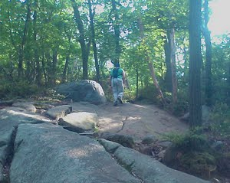
Our group generally consists of college, post-college, and working professionals (roughly ages 18-35). Before the summer ends, we are looking to create a venue for young adults in the area to meet new people.

We know how impossible it is to meet people in such fast-paced, often-too-busy lifestyles we all live. If you are meeting people only on the Internet by their screen names – this is for you – join us and come meet some real people!

And yes, you can bring friends or come with a group!

So, come and meet some new people
as you hike up the mountain
(and get a workout while at it!)

The details of the climb is on our website – go check it out and sign up for the hike there

Please sign up early so we know how much kimbap to prepare. You can sign up by going to http://www.to1another.com – there are links to facebook for signing up. If you are bringing a group, you can sign up using the form at the website. If you have further questions or concerns, you can ask questions on the website or facebook or by contacting one of our members directly.

What to bring:
Sneakers or hiking boots
Comfortable clothing – those that fear bugs should wear long sleeves/pants
Cameras (why not?)

